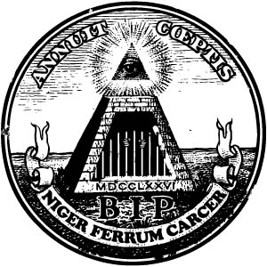
The World’s Oldest And Most Successful Conspiracy
Bavarian Illuminati
Founded by Hassan i Sabbah 1090 A.D. ( 5090 A.L, 4850 A.M)
Reformed by Adam Weishaupt 1776 A.D ( 5776 A.L, 5556 A.M)

( ) Official Business ( ) Surreptitious business

FROM:

